## Book Library

Create **templates** for **all items** on the page, as you see fit. See the file example.html for an example of how the rendered HTML may look like. You are free to add attributes that would help you implement the required functionality.

### Get All Books

First task is to "**GET**" all books when the button "Load All Books" is clicked. To consume the data from the API, send a request to the **following URL**: **http://localhost:3030/jsonstore/collections/books**

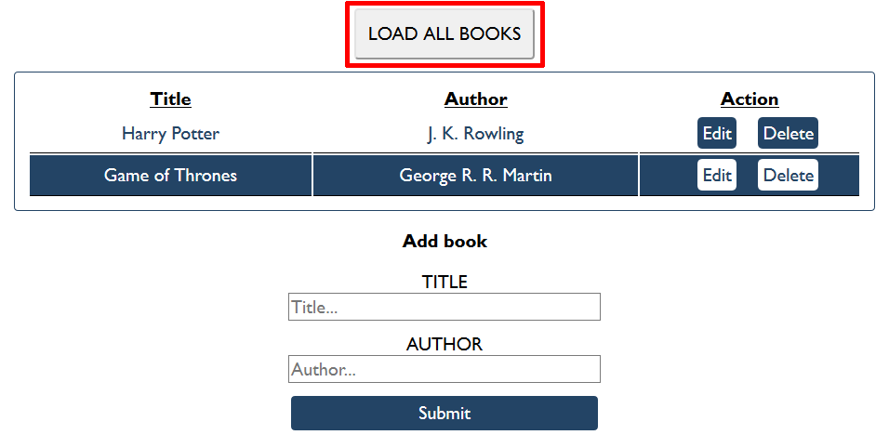

### Create Book

Initially, the form with **id "add-form"** should be displayed. Write functionality to create a new book, when the submit button is clicked. Before sending the request be sure the fields are not empty (make validation of the input). To **create** a book, you must send a "**POST**" request and the JSON body should be in the **following** format:

{

"author": "New Author",

"title": "New Title"

}

### Get Book

Send a "GET" request to the following url:

**http://localhost:3030/jsonstore/collections/books/:id**

### Update Book

By clicking the edit button of a book, display the form with **id "edit-form"** and populate its fields with the information from the selected book:

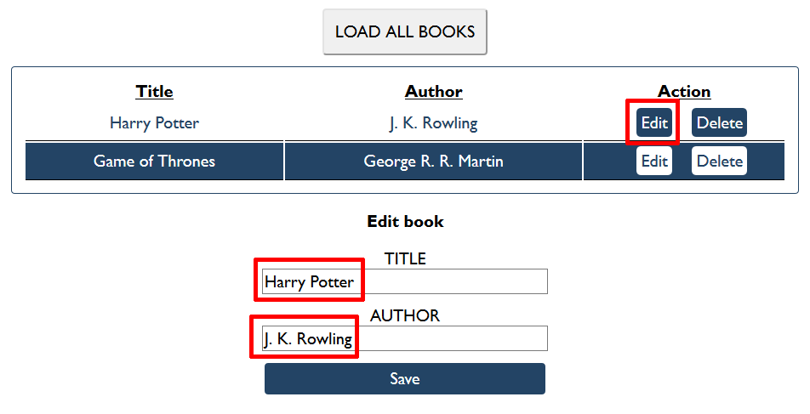

The HTTP command "**PUT**" **modifies** an existing HTTP **resource**. The URL is:

**http://localhost:3030/jsonstore/collections/books/:id**

The JSON body should be in the **following** format:

{

"author": "Changed Author",

"title": "Changed Title"

}